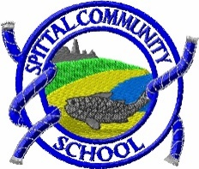
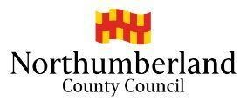
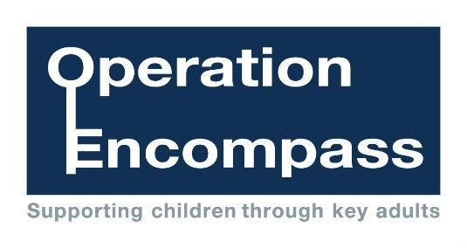

May 2023
Dear Parent/Carer
I am writing to inform you about Operation Encompass. This is an innovative project in which schools in Northumberland are participating, and which is run in partnership with Northumberland County Council and Northumbria Police. Many other Local Authorities both nationally and locally have successfully implemented Operation Encompass.
Operation Encompass aims to support children and young people who are affected by domestic abuse. Experiencing domestic abuse is really distressing for a child or young person, who often see the abuse, hear it from another room, see a parent’s injuries or distress afterwards or can be physically hurt by trying to stop the abuse.
As a result, following any domestic abuse incident being reported to the police, the Police will make contact with Children’s Social Care who will then communicate relevant and necessary information to nominated school staff. This will ensure that the school is made aware at the earliest possible opportunity and can subsequently provide support to children in a way that means they feel safe and listened to.
Each school has members of staff (key adults) who have been fully trained in liaising with police and Children’s Social Care when required, and will ensure that the necessary support is made available to the child or young person following the disclosure of a domestic abuse incident.
I believe that this project demonstrates our school’s commitment to working in partnership to safeguard and protect children, and to providing the best possible care and support for our pupils.
In the meantime, if you would like to speak to someone further about the project or require further information, please contact our key adults in school who are Mrs. Kiff and Miss. Richards
You can also find out more information regarding support that is available for adults and children here http://www.operationencompass.org/
and
https://www.bbc.co.uk/programmes/p03y9r5h
Yours,
Mrs. W. J. Kiff
